#Drone Pilot License Test

sUAS FAA certification

COMPILATION OF MATERIALS FROM DIFFERENT SOURCES THROUGH THE INTERNET. READ AT YOUR OWN RISK. HOPE THIS COULD BE USEFUL.

Create a account here at FAA and get FRN number <https://www.faa.gov/uas/commercial_operators/become_a_drone_pilot>

Then using that number register here and take a date: <https://faa.psiexams.com/FAA/login>

1. Nice overview of a lot: <https://aspire.unm.edu/resources/modules-documents/files/part-107-exam-study-guide.pdf>

Create FAA account first.

**Federal Aviation Administration - FAA**

The FAA has developed regulations to allow the operation of small, unmanned aircraft systems (sUAS) in the National Airspace System (NAS) for purposes other than limited recreational use. The rules are specified in 14 CFR part 107 and address UAS classification, certification, and operating rules.

Ta7655828562

1. From FAA is their guide that cover just about everything but is somewhat dense. <https://www.faasafety.gov/gslac/ALC/course_content.aspx?cID=451&sID=726&crID=1436761>
2. This guide and additional info have some more helpful info. <https://jrupprechtlaw.com/part-107-test-study-guide/>
3. This video is very helpful for sorting out kind of what to focus on for the test, though it doesn't have all the supporting info you might. <https://www.youtube.com/watch?v=6_ucCKFJUCU>

To fly drones commercially

Eg. Real estate business, wedding photography,

<https://northrup.photo/free-faa-part-107-suas-drone-certification-study-guide/>

Another website for materials and information: <https://www.halfchrome.com/how-to-pass-the-faas-part-107-exam/>

Numbers:

* Around 63-64 questions and need 70% to pass it.
* Multiple choice test: 3 choices… 1 easy eliminator
* Minimum UAS: 0.55 lbs. all drones need to be registered.
* If weight is less than 0.55 lbs, then don’t have to register.
* Maximum UAS: 55 lbs
* Age to register: 13, to register for drone
* Can take test when 16.
* Valid upto 24 months ( 2 years)
* 400 feet AGL: can fly upto that height, not above bcz of safety for other flights
* Only in case of emergency can fly over that but need to tell FAA
* 400 feets over ground or building i.e. if building is 1000 feet, can fly upto 1400
* 500 feet below clouds: ie. You check weather and found out clouds are at 800 feet, then 800-500 = you can fly upto 300 feet only
* 2000 feet horizontal from clouds
* 2000 feet away from wire guy
* **so, have to stay 2000 feet away and then 500 feet below cloud and 400 feet above ground/building**
* 100 MPH speed ( legal speed), rules can be broked if needed after getting waiver from FAA
* 3 SM visibility: 3 statued miles have to maintain visibility
* 8 hours without alcohol: wait 8 full hours even after a beer
* 0.04 blood alcohol level: this is must. If 8 hours after alcohol intake but still BAL is over 0.04, you can’t fly.
* 1 year after narcotic conviction:
* 30 minutes of twilight ( 30 minutes after and before sunlight). But you can fly if you have anti-Collison lights which are large big lights that increase visibility.
* $ 500 minimum damage for FAA report: limit that FAA draws before filing drone accident. Need to file only if you damange someone else’s property, if its just your drone damage, no need to file. Also file if seriously injured i.e. have to go to hospital
* If needed to file, 10 days to file FAA report

Airspace rules: <https://aspm.faa.gov/aspmhelp/index/Airspace_Classification.html>

* Class A airspace
* Class B: for biggest airport, has 3 tiers
* Class C: for regional airport, small airport, have 2 tiers
* Class D: small one,
* Class E
* Class F

A>B>C>D>E>G in terms of restrictive… A normally too high to fly, so B possible most restrictive one and E the lease generally

Radio Info.

Still use radio

CTAF: If pilots are coming down for landing or …. It’s a frequency

Multicom: 122.9 or 122.95 ( reserved frequencies for really small airports)

Unicom: same as CTAF,

AWOS: for weather prodcast

Radio Talk: ATC language

Niner:

Alpha, Bravo, Charlie, Delta: Adds clarity to recognize words

Alpha, Bravo, Charlie, Delta, Echo, Foxtrot, Golf, Hotel, India, Juliett, Kilo, Lima, Mike, November, Oscar, Papa, Quebec, Romeo, Sierra, Tango, Uniform, Victor, Whiskey, Xray, Yankee, Zulu

Physics:

Stalls: exceeds critical angle of attack. It happens when that angle exceeded. when increase stall speed, makes things bad.. A stall occurs when the smooth sirflow over the unmanned airplane’s wing is disrupter and the lift degenerates rapidly, which is caused by exceeding critical angle of attack.

Load Factor: Increases during turns, and if exceeded load factor. Load factor times the weight of flying object. Load factor calculated from bank angle ( graph, for 30 degree, 1.1 load factor, for 60, 2)

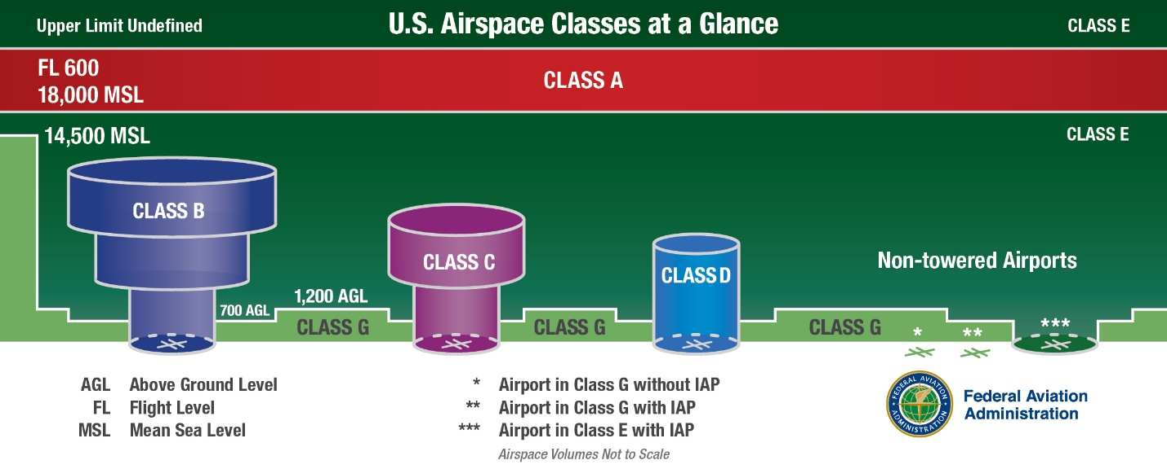

Center of Gravity:

Pilot’s operating Handbook or UAS Flight Manual: The answer to check CG

**Sectional Charts: or Maps**

sdp.io/chart : check your area

Pilot is required to have one of the area they are flying

Legend helps to understand those charts

Airspace on charts:

Eg. 70/20 means 7000 (two zeros) feet of the ceiling at that airport and 2000 feet at the floor of the airspace.

MSL: Above sea level, AGL: Ground level and always use MSL in the FFA

Red flag in map: VFR( Visual Flight Rule), there might be more planes here, beacon area

41/SFC means 4100 above ground level (i.e. Surface for SFC)

510(233) : MSL and AGL and then subtract to get altitude ( not two zeros here)

Parachute symbol: possible sky divers area.. which can fly around 400 ft, so do not fly there.

Or gliders will be there too

CTAF:

MOAs: Military Operation Areas: might have town and neighbourhood but they might have cargo’s or used to be military area. Also, it does not mean that you can not fly, but FAA want you to be cautious and check info on sectional

Military Training Route(MTR): eg. IR037 or VR1667

Latitude & Longitude: Latitude goes N to S like ladder and longi is E and West as its flat somewhat. Latitude: North and South of Equator, and Longitude: east and west of Greenwich

0 latitude is equator… 70 degree west of Greenwich London, UK ….

1 tick mark on the axes is a minute.. so 70 degree and 10 minute is on west of 70 degree for longitude

And for latitude, no. goes up going towards the north but for longitude, it goes up towards the west.

True and magnetic north: In the charts, mostly true north shown. Magentic north that is shown by magnets, true ones are the ones that leads to equator and is true one.

Airports: just don’t fly in airport

Runway Patters: Planes land and fly taking advantage of wind so runways are mostly designed like that. They fly off and turn left on the circle… like in car its easier to see tower and runoff from left where the seat is.

**Runway Markings**: 0 degree is North, 90 degree is east, 180 is south and 270 is west ( runs clockwise) so Runway 9 is oriented 90 degree to the east, runway 27 (270 degree) facing west and runway 13 is 130 degree which is between 90 and 180 so between east and south so southeast.

Always land in uphill. Need to practice by drawing pictures.

**Wind and Aircraft type:**

Headwind if the direction of wind is opposite to the direction of aircraft

If same direction, tailwind and if perpendicular is called Crosswind.

While taking off, headwind is preferred bcz it creates the lift. IAS = ground speed + wind speed in headwind, but if tailwind condition, then its minus and thus for such condition, aircraft need longer runway to get to that momentum.

User Manual: look for things on battery and all maintenance or other stuff

Maintenance Schedule: mostly provided by drone companu, and then maintain urself if not provided.

Sectional Charts: …

Details are in **chart supplements** (it’s a book and has more impormation)

NOTAM (Notices to Airmen): it will have times to follow some regulations, timely and emergency stuff. To check this go to: **1800WXBrief.com, not FFA app**

**METAR and TAF (Terminal Aerodrome Forecast): PROVIDE WEATHER INFO.**

**METAR: Looks horrible. 1st word is METAR, 2nd is K_ _ _ i.e. name of airport eg. KJFK, then its UTC time i.e 161753K ( so day of month and then time of that day is 1753 i.e. 5 53 PM), AUTO ( or COR for corrected), then 5th one is wind speed e. 14021G26KT( 1st 3 indicate compass heading, then speed i.e. 21 NARTS to 26 then Gausting and then KT is abbreviation for wind speed. VRB is for variable wind at 5 narts (VRB05KT), then SM represent distance of visibility so ¾ SM is for ¾ mile is visible i.e 0.75 mile). Also then +TSRA BR (indicates thunderstorm and rain, BR is Mist), there is a chart for it. Plus for heavy… only remember common one like SH, TS, RA…**

**BKN008 i.e broken clouds at 800 feet, OVC)12CB : overcaust at 1200 feet so its type of cloud, then another chart for this as well, at last 18/17 means temperature and dew point in Celsius (dew point for showers ..) There might be more info.**

**Reading a TAF Report:** Terminal Airdrone Forecast, very hard to look at… TAF means its TAF report, then airport name, then Z at last means Zollo is UTC time(day, time), then how long this report is valid for (start and end there), then TEMPO means temporary, then period of time 1112/1114, SM for statued mile is for visibility, BR for mist, KT stands for Nauts i.e. wind speed,

SM: for statued mile for visibility

SCT040 for clouds (scattered clouds at 4000 feet), BKN broken clouds

FM120000: From 12 a clock at midnight,

KT for wind speed,

OVC: overhaust

* - / - - means time with slash

So TAF has some info for particular time and then again changes

Denstity Altitude:

Low DA: high altitude, so less air and very thin air means poor lift and thus less efficient in flying.

High DA:

Fronts: Divide weather patterns. Fronts is the separation of two hot and cold type weather

Wind shear: sudden drastic change in wind speed and can happen in any altitude and can be dangerous. If wind shear exceeds speed of drone,then can hamper.

Structural Icing: ice forming on wings. It can happen on precipitation at cold or below 0 defree

Life cycle of TS:

1. Cumulus: initial phase that might or might not be mature
2. Mature is dangerous
3. Dissipating: downdraft start to see

Humidity: makes hazier, air heavier, reduce visibility

Hot and Humid air becomes unstable air

Turbulence is caused by unstable and shower air.

Stable Air: heacy sir, visibility poor, and result in steady rain: characterstics: poor visibility and steady precipitation

Nimbus are big heavy clouds

Stratus: high whispy clouds

Team

Visual Observer (VO): just observe

Remote Pilot in Command (PIC): us… inspect and maintain, and determine performance of drone, and almost everything related to drone. Except observing and helping PIC done by VO.

CRM: Crew Resource Management:

Risk: Hyperventiliation (breathing too much), don’t breathe more and try to calm down

Alcohol is bad when you have to fly.

Hangover: still under the influence of alcohol

Fatigue: bad, is an impaired state

Scanning the sky: look for movements.. systematically focus on different segments of the sky for short intervals.

**Macho**: show off to prove they are great and something and then do sth stupid

Impulsivity: doing without planning so an antidote is proper planning

Invulnerability:

Resignation: people who already resigned and become careless

Anti-authority: who opposes rules and authority

Crew Resource Management (CRM): important in preventing accident chain

Study & Cram: look through some facts in your notebook and then write down some…

Use process of elimination: mostly one dumb option

Mark questions: to comeback and check again

Don’t stress: